**Illustrator**

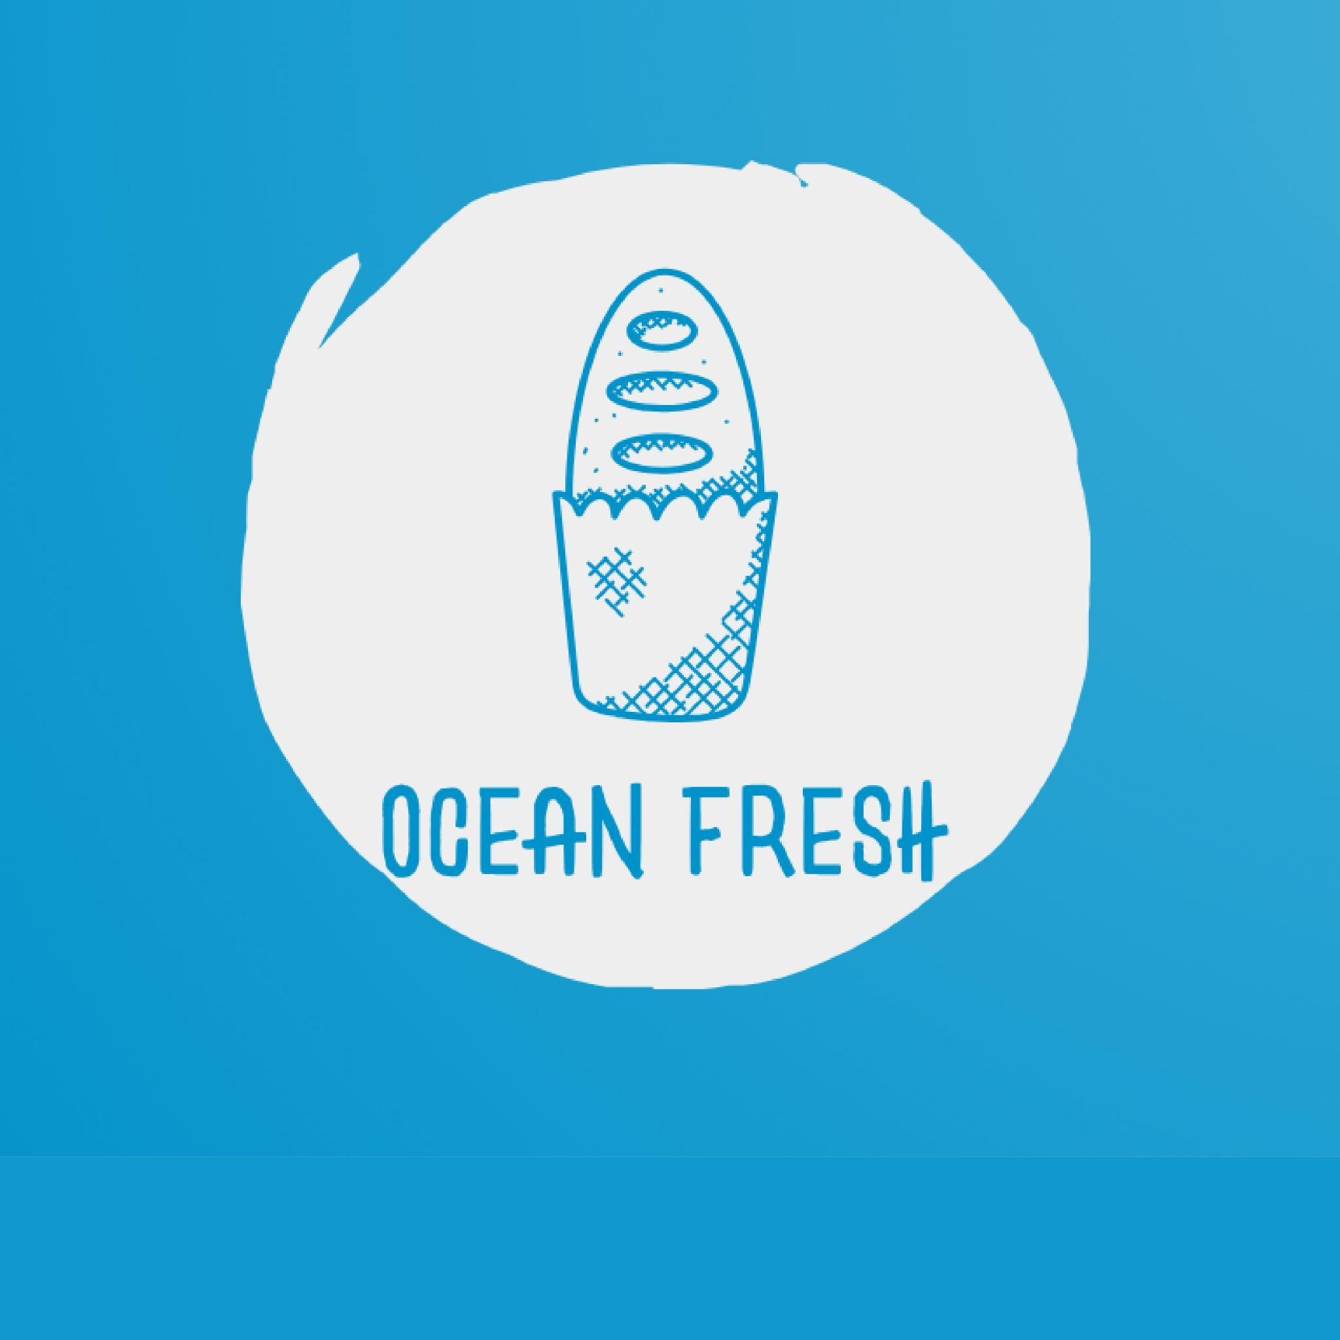

Minimalist seafood logo featuring waves and a cone and oceanic freshness

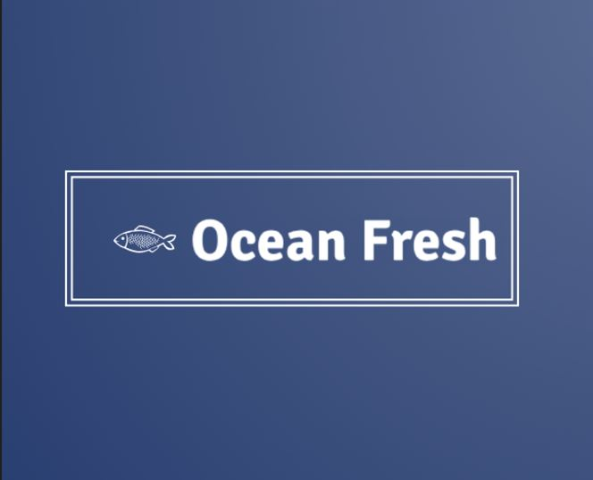

Seafood logo with fish icon and clean typography

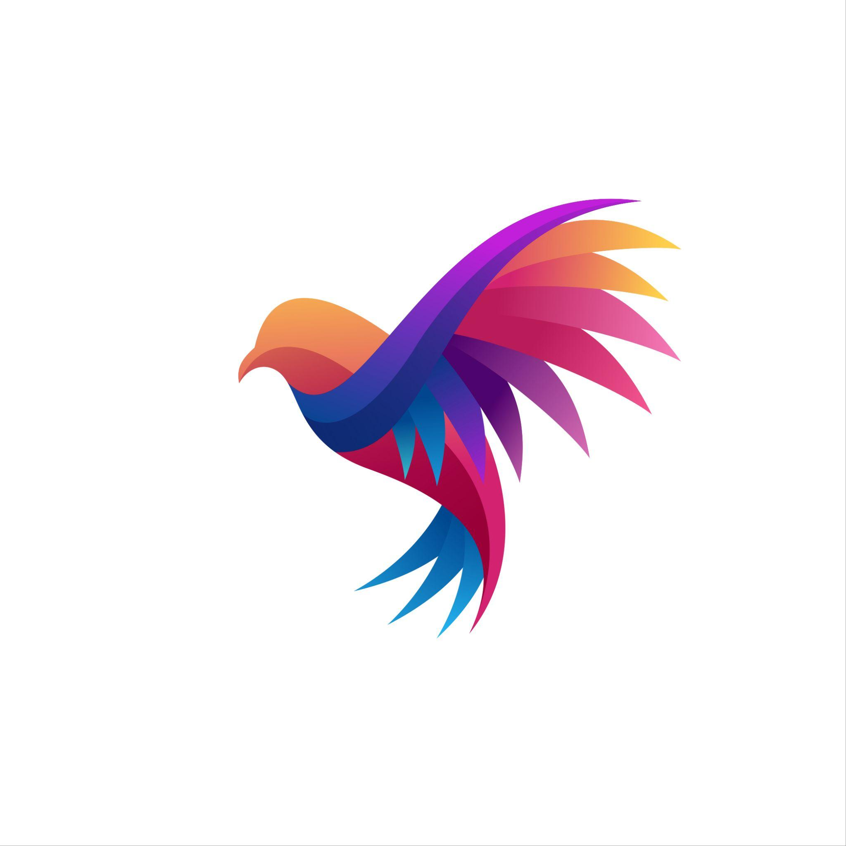

A Multicolored bird logo symbolizing freedom and creativity

**Photoshop**

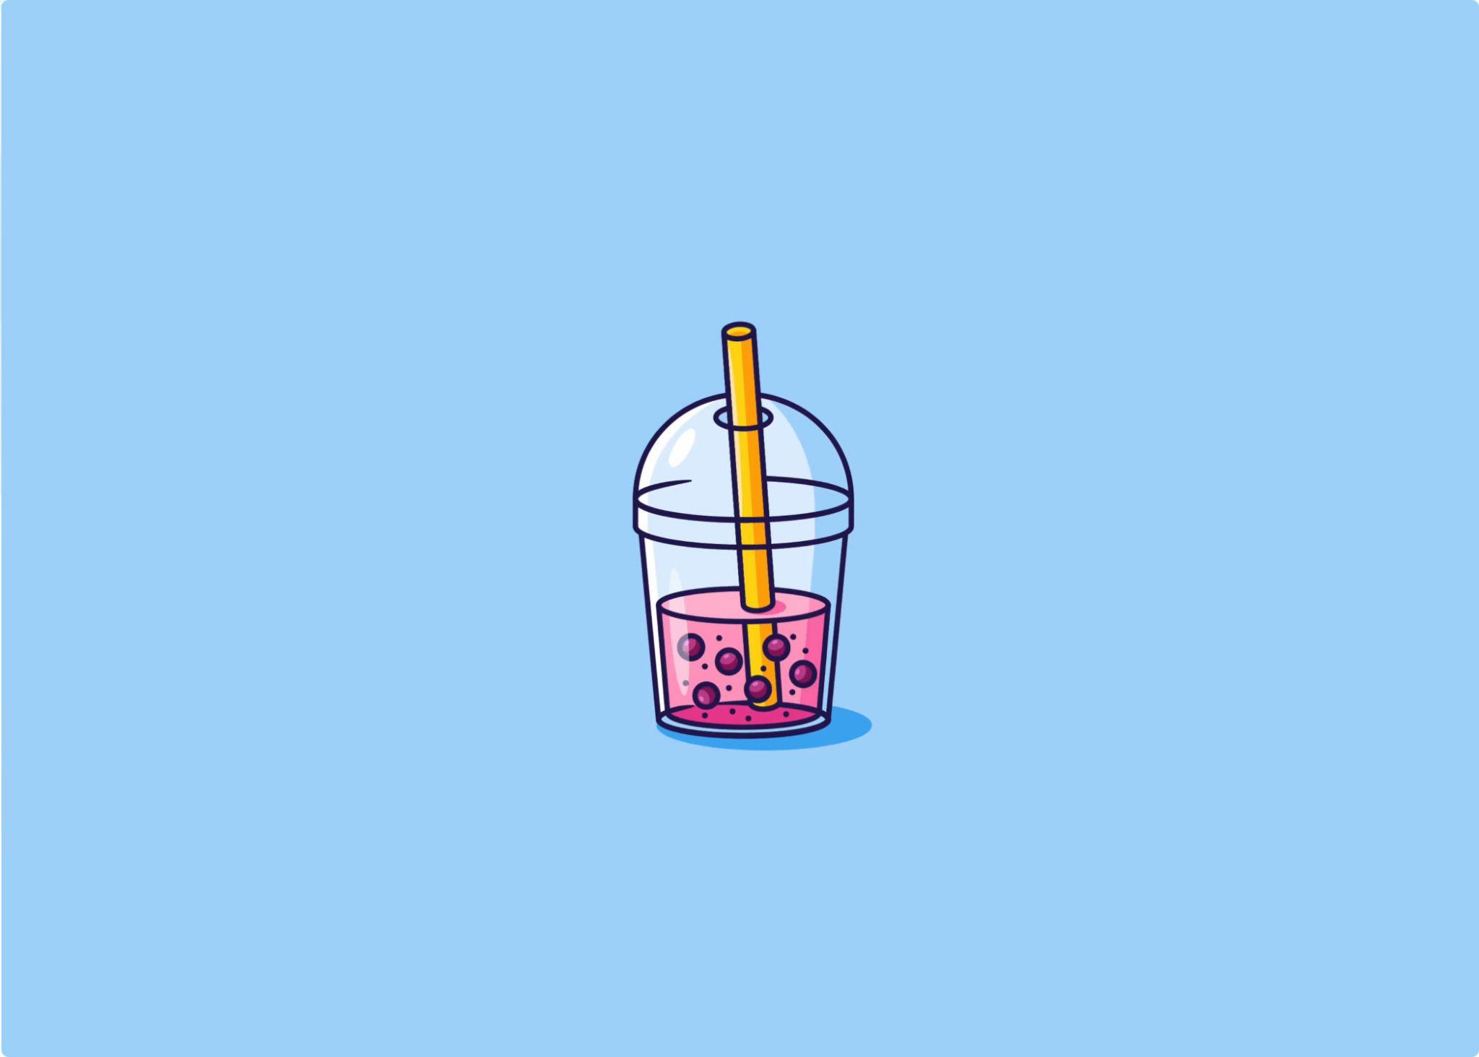

Boba tea with tapioca pearls in a vibrant presentation

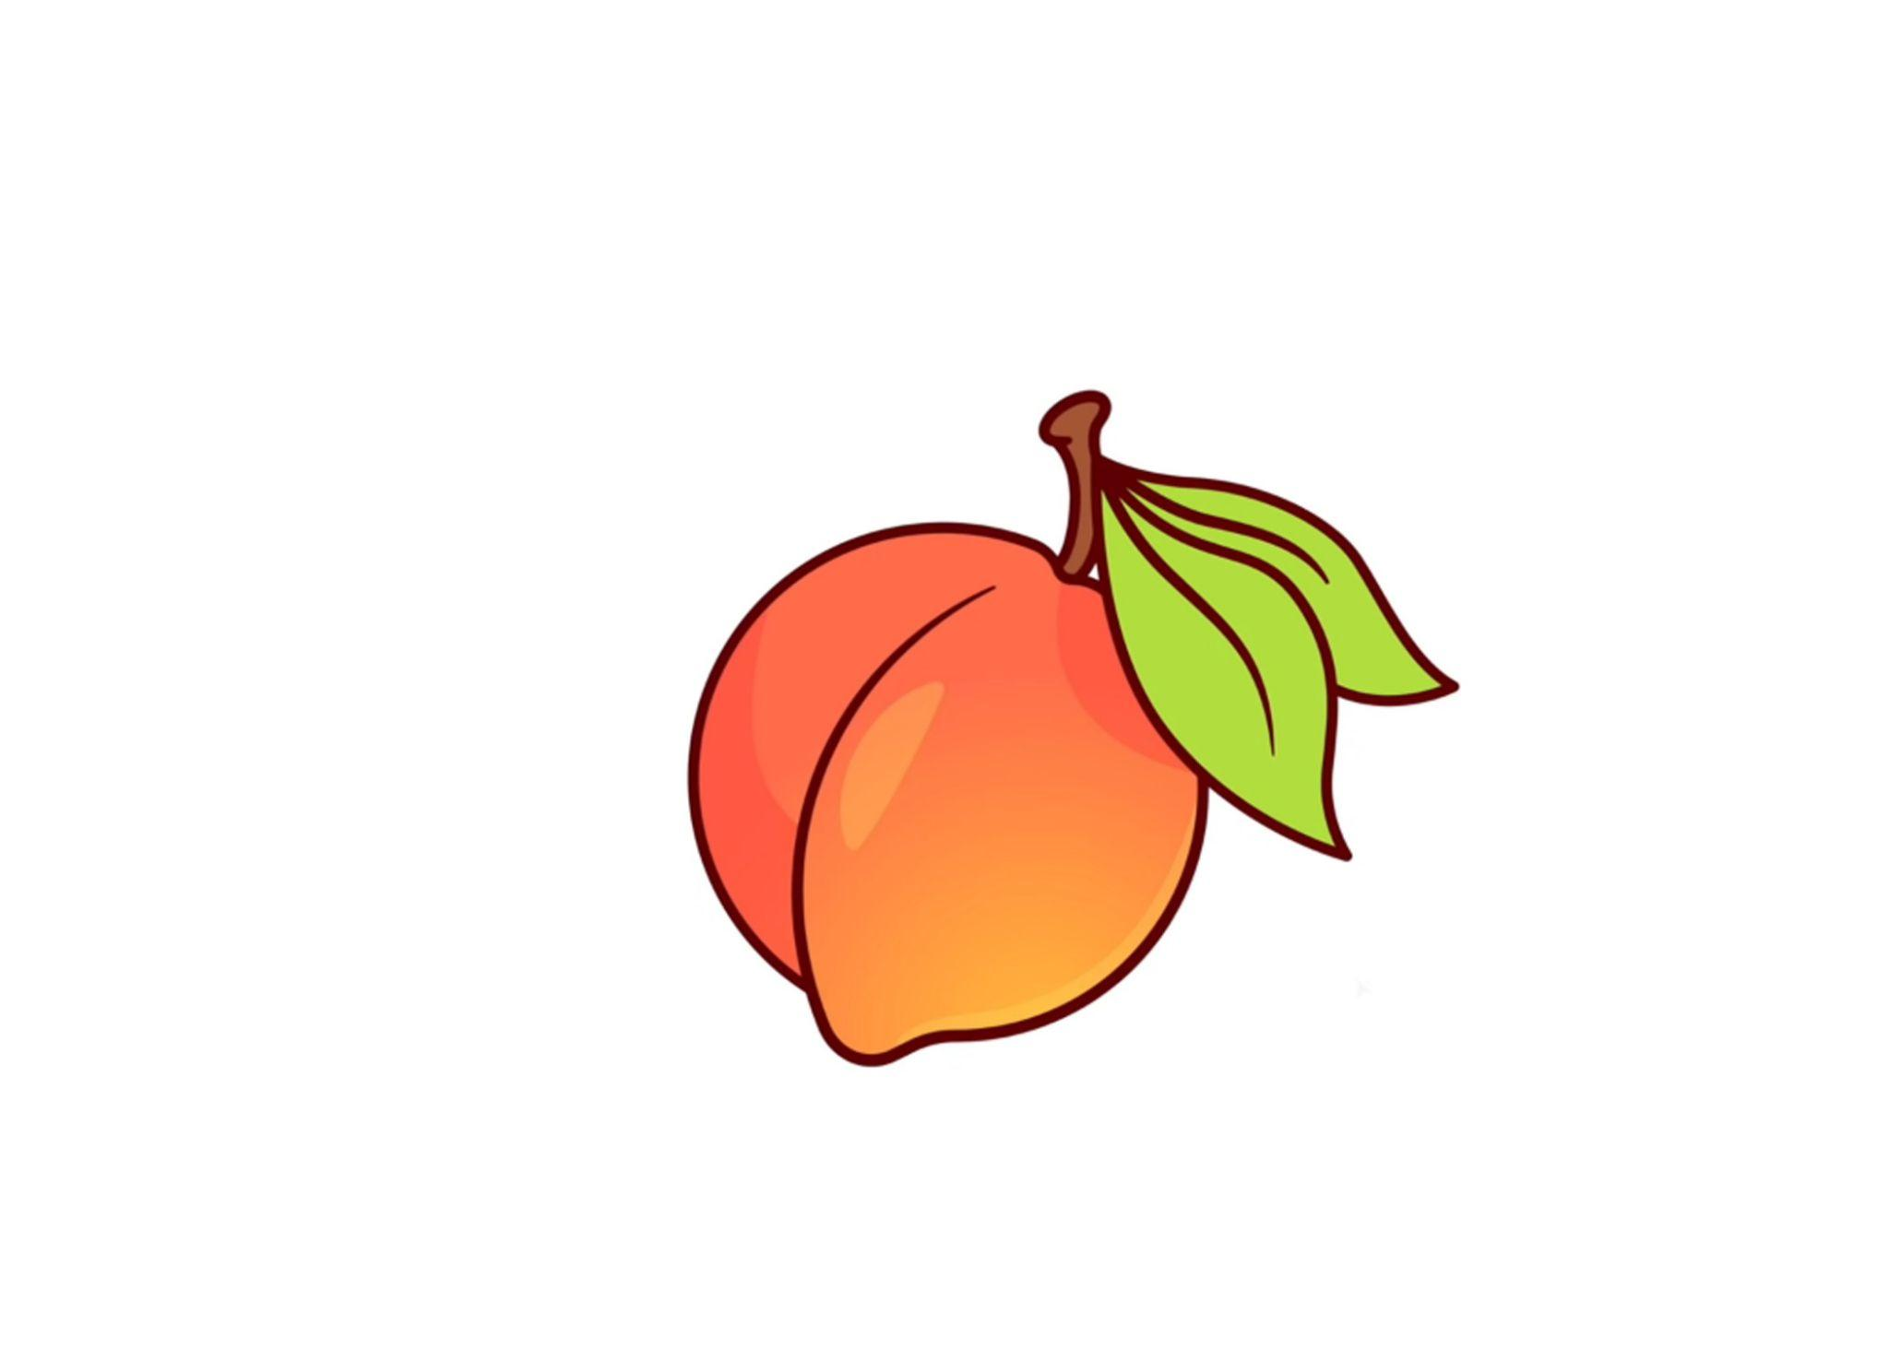

A peach with a bright golden hue

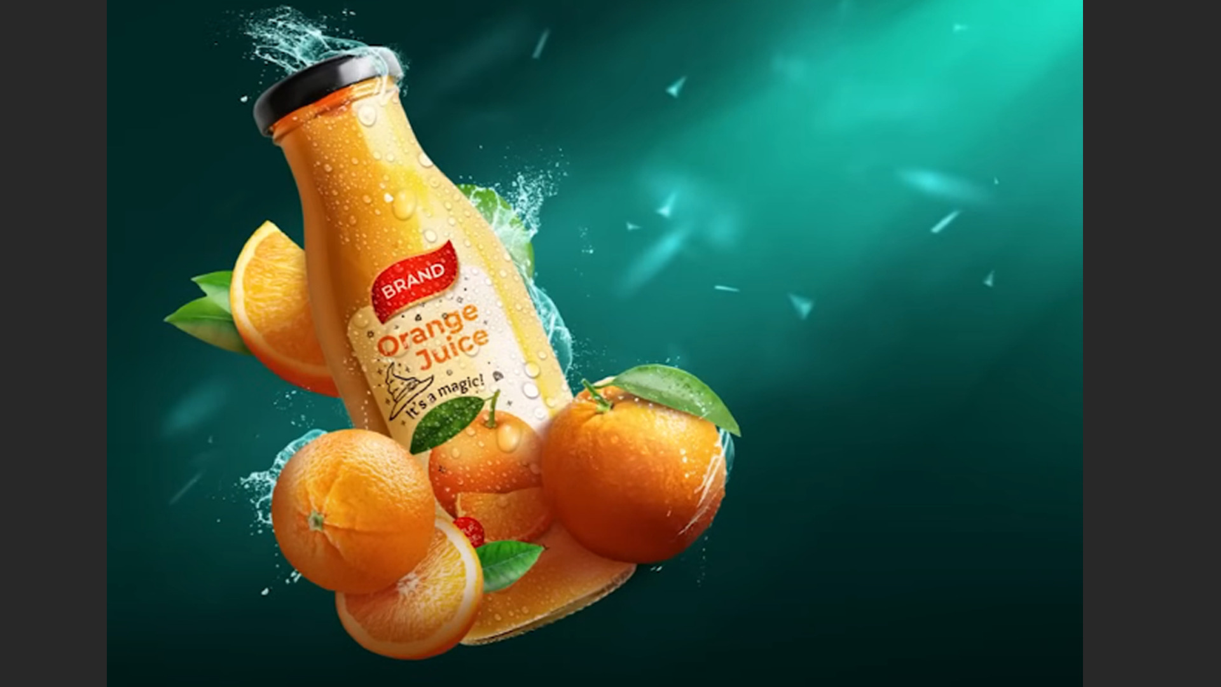

An orange juice bottle with fresh oranges

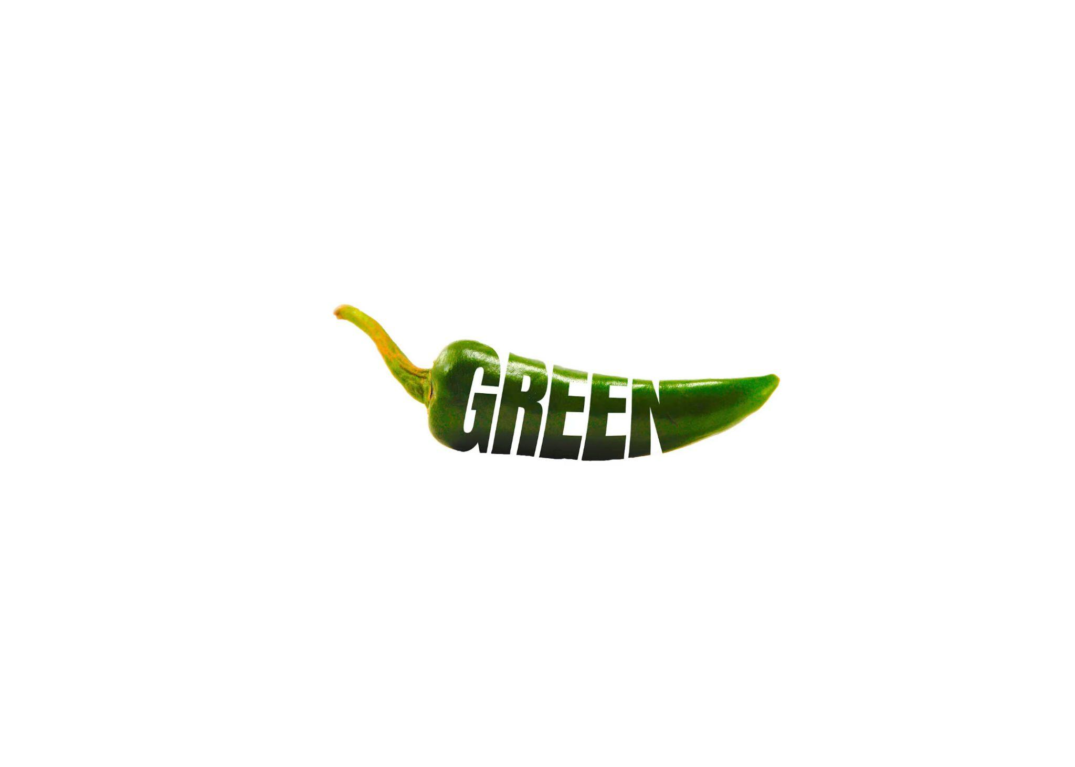

A bright green pepper with typography



A cheesy slice of pepperoni pizza

A sliced-up bursting strawberry

**Photo change**



| File name | Current card text | New card text |
| --- | --- | --- |
| photoshop2.jpg | Card 1 | Promotional flyer showcasing a seafood cioppino special offer |
| photoshop3.jpg | Card 3 | phrase "KEEP PACE" in bold text, arranged like ascending steps |
| photoshop4.jpg | Card 2 | Emphasizing "depth" by visually integrating it as text descending into a well-like perspective |